3

Invitation for Advisory Board Member
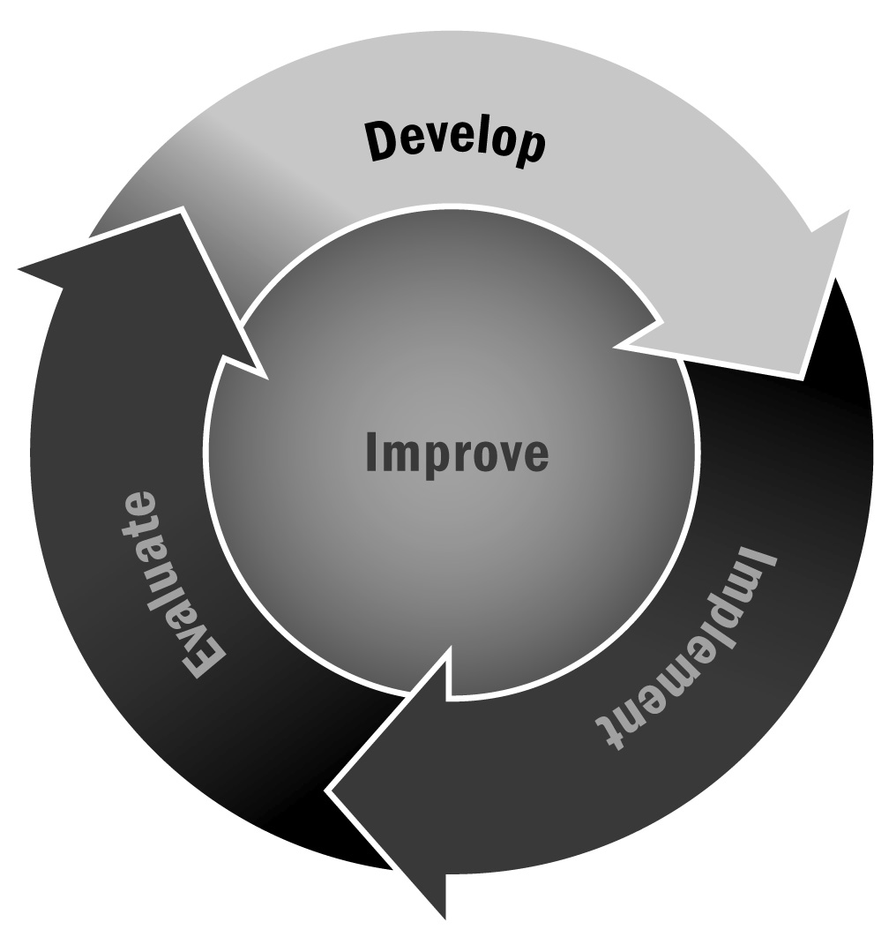
In Chapter 1, you learned that advisory boards are important for providing guidance and support as you develop your program. Recruiting advisory board members early in your program development process can help them feel ownership of the program and provide you with much needed start-up input.
Directions: Use the following template when you are inviting individuals to join your advisory board. The made-up invitation on the next page provides a sample of tone and language. Adapt and adjust it for your specific program and for the person you are inviting to participate on your board.

Tips for Written Communication
- Adapt and adjust all communication for your specific program and the person with whom you are communicating. Personalize whenever possible—refer to how you know the person, ask about something in his or her life, or simply wish the person well!
- Alter the format of your communication to fit the method you are using to communicate.
- If you are sending an email, for example, make sure your subject line clearly identifies the purpose of your email. An email that says “Invitation to Join ABC Afterschool Program Advisory Board” is much more informative and likely to get the attention of your recipient than “Invitation.”
- Make sure your contact information is always included in your email signature.
- If you are sending a letter or memo, be sure to include the date and always sign your name at the bottom.
- If you are communicating via letter or a printed memo, use your program’s letterhead. If you do not have letterhead, use brightly colored paper.
- Remember to proofread the invitation, and follow up your letter, memo, email, or other written communication with a personal phone call. Taking a little extra time can go a long way.

Dear Ms. Garcia,
Greetings! I hope this email finds you well and enjoying the start of the school year. It was great seeing you last week at the back-to-school picnic. As you may know, I recently received a grant from the state Department of Education to develop a 21st Century Community Learning Centers (21st CCLC) program for the students at Jefferson Middle School in the West End neighborhood. This is an exciting opportunity to serve the young people of this community!
Although it is still early in the planning process, our intention is to serve approximately 300 youth in grades
6–8. Our program will be open five days per week after school until 5:30 starting in January, and will focus on preparing youth for high school with a mix of academic enrichment, homework help, sports, arts, and social development programming.
We are putting together an advisory board of representatives from all the groups that have a key stake in the implementation and outcome of this program to ensure our program meets the needs of families and youth in the school, identifies strong partners, and takes advantage of this community’s tremendous assets. Given your leadership of the West End Community Center, your deep understanding of the needs of families and youth in this community, and your strong relationship with the Jefferson school faculty, I would like to invite you to participate on our board. Your advice and insight into our program design and approach would be invaluable.
We anticipate convening the advisory board once every other month for approximately 1–2 hours. Meetings will be held at mutually agreed on times and locations. Outside of the meetings, I don’t anticipate a large time commitment. We may ask advisory board members to volunteer for specific activities from time to time, but only on an as-desired basis.
I hope you will consider joining this important board and helping to shape the direction of the 21st CCLC at Jefferson Middle School. Your input and guidance will make it a better program. Please let me know if you have any questions or would like to discuss this further. I can be reached at 000-000-0000 or sampleemail@gmail.com. I hope to have the board members identified by September 25 and to hold our first meeting in the second week of October. If you can let me know by then if you are able to serve, I would appreciate it.

My best,

Jennifer Smith
Program Director

